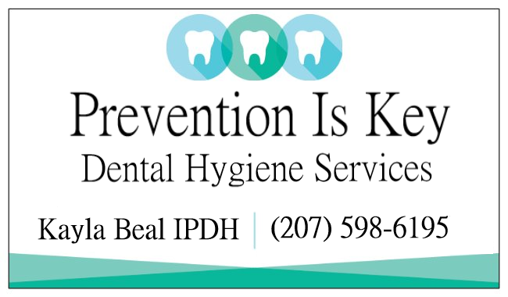

Welcome to Prevention Is Key! We are so excited you chose us for your dental care!
A smile is a very powerful thing, and a healthy smile is even more valuable to your full body health. We are eager to make you feel comfortable, informed, and appreciated.
We encourage you to contact us if you have any questions prior to your appointment. We are looking forward to meeting you as well as taking care of your dental needs!
This packet includes:
- Release of Dental Records (to send to your previous dental office)
- HIPPA (Health Insurance Portability and Accountability Act)
- Patient Registration
- Medical History
- Office Policy

Please fill out the included paperwork. Send the Release of Dental Records to your previous office to receive records before your scheduled appointment. The remaining paperwork send to our email preventioniskeyipdh@protonmail.com or by mail P.O Box 328 Milbridge, Maine 04658.

Or you can bring the paperwork with you to your first appointment. If you would rather fill out the required paperwork in the office before your appointment time; we will have them ready for you.

Patient Information Form Date_____________
Patient Name:__________________________ MI____ Last_____________________________________
Is the patient a Minor? YES NO Date of Birth______________________ Age_________ M F
Name of Responsible Party: ________________________Relationship to Patient___________________
Address: Street_________________________ City________________________State________________ Zip______________ Phone: Home__(_____)_________________ Mobile__(_____)_________________
E-Mail address _________________________________
Preferred method of contact? O Home Phone O Call Cell Phone O Text Cell O E-mail
Emergency Contact
In case of emergency, who should be notified? _______________________________________________
Relationship to Patient________________________________ Phone #___________________________
Dental Benefit Plan Information
Primary Dental Plan Name_______________________________________ Phone #_________________
Name of Insured__________________________ Date of Birth__________________ ID #_____________
Policy #_________________________________ Patient Relationship to Insured____________________

Secondary Dental Plan Name______________________________________ Phone #________________
Name of Insured__________________________ Date of Birth__________________ ID #_____________
Policy #_________________________________ Patient Relationship to Insured____________________

Please provide office staff with your Dental Insurance Card to make a copy for reference.
Thank you!
PATIENT HIPAA CONSENT FORM
I understand that I have certain rights to privacy regarding my protected health information. The rights are given to me under the Health Insurance Portability and Accountability Act of 1996 (HIPAA). This provides a safeguard to my privacy.
What this is all about: Specifically, there are rules and restrictions on who may see or be notified of your Protected Health Information. (PHI). These restrictions do not include the normal interchange of information necessary to provide you with office services. HIPAA provides certain rights and protections to you as the patient. We balance these needs with our goal of providing you with quality professional service and care. Additional information is available from the U.S. Department of Health and Human Services. www.hhs.gov
We have adopted the following policies:
- Patient information with be kept confidential except as is necessary to provide services or to ensure that all administrative matters related to your care are handled appropriately. This specifically includes the sharing of information with other healthcare providers, health insurance payers as is necessary and appropriate for your care.
- It is the policy of this office to remind patients of their appointments. We may do this by telephone, e-mail, U. S mail, and/or as requested by you. We may send your other communications informing you of changes to office policy and new technology that you might find valuable or informative.
- You understand and agree to inspections of the office and review of documents which may include PHI by government agencies or insurance payers in normal performance of their duties.
- You agree to bring any concerns or complaints regarding privacy to the attention of the staff.
- Your confidential information will not be used for the purposes of marketing or advertising of products, goods or services.
- We agree to provide patients with access to their records in accordance with state and federal laws.
- You have the right to request restrictions in the use of your protected health information and to request change in certain policies used within the office concerning your PHI. However, we are not obligated to alter internal policies to conform to your request.
- Is there anyone that you provide permission to answer appointment confirmation calls? If yes, who:___________________________ relationship to you_______________________

I_________________________ date______________ do herby consent and acknowledge my agreement to the terms set forth in the HIPPA INFORMATION FORM and any subsequent changes in office policy. I understand that this consent shall remain in force from the time forward.
SIGNATURE OF PATIENT, PARENT, or GUARDIAN________________________________________

Office Policy
We are dental prevention specialists. By seeing your Dental Hygienist on a regular basis, you help prevent dental disease and increase your bodies overall health.
A Dental Hygienist is not (by law) allowed to diagnose or restore cavities or periodontal disease. For areas of concern or suspected oral disease, we will refer you to a dentist or specialist (of your choice) for further evaluations, diagnosis, and treatment. We recommend our patients to have a yearly visit with their Dentist.

COVID 19
Please contact the office if 14 days after your visit you test positive for COVID-19.

Financial Policy
Our primary goal is not to allow the cost of treatment to prevent you from benefiting from the quality care you need or desire. Our fees are based on the quality materials we use, and the time, effort and skill required in performing your needed treatment. We will assist you with your benefit eligibility before treatment to help you calculate your costs. We will be sensitive to your financial circumstances and do everything possible to help you achieve oral health.
Ultimately, however, you are responsible for payment regardless of any insurance companies’ arbitrary determination of usual and customary rates.
We are happy to submit the claims necessary to see that you receive the full benefits of your coverage; however, we cannot guarantee any estimated coverage. We accept the following forms of payment: Cash, Check, Visa and MasterCard. Most dental insurances and Mainecare. For patients that are self-pay, payment is due the day of service.
Please feel free to contact our staff at any time to discuss any concerns you may have. Thank you for understanding our Financial Policy.

Rescheduling / Change in Schedule Policy
Our practice is dedicated to quality care and exceptional service. Broken and missed appointments create scheduling problems for our team as well as other patients. If you find that you must change your appointment, we require a minimum of 48 hours’ notice so that we may make every effort to accommodate other patients. We understand that life is busy. If an appointment is missed, you will receive a written warning by mail. If you receive two written warnings, two failed appointments, then you will need to pay the full appointment fee before re-scheduling. You will not be reimbursed for the missed appointment.
With your permission we will use your name and telephone number for an automated texting system to remind you of your upcoming appointment.

I have read and agree to the Office Policy, Financial Policy and the Cancellation Policy of Prevention Is Key.

SIGNATURE (PATIENT, PARENT or GUARDIAN) ________________________________ Date: __________

I, __________________________, hereby request and give my permission for _________________________
(patient, parent, or guardian) (previous dental office)

to provide Prevention Is Key with any information regarding past dental care for _______________________.
(patient or child’s name)

Signature: ______________________________________________ Date: ______________________
(Patient, parent, or legal guardian if the patient is a minor)

Please have previous dental radiographs, periodontal charting, and clinical notes sent to

Email: preventioniskeyipdh@protonmail.com
OR
Mail: P.O Box 328 Milbridge, ME 04658
For any questions please call Prevention Is Key at (207)598-6195.

Thank you!

